**Contents**

Business Rules for Chicken_OutletsDB 2

EERD Diagram 3

Dbeaver ERD Drawing 4

SQL Query for the receipt (Transaction/Sale): 5

Transaction from KFC Pretoria Central: 6

The SQL statement below shows all the transaction from a franchise: 7

The SQL statement below shows all the transaction from a franchise: 7

# Business Rules for Chicken_OutletsDB

* A restaurant is a franchise of different branches (franchisees).
* Each branch (franchisee) belongs to one and only one restaurant (franchise).
* A branch is located at a restaurant location which is the physical address of the branch.
* A branch is managed by only one employee with a manager role.
* Not all employees are managers.
* An employee only works for one branch.
* An employee can capture or record a transaction (record a sale) working at a till point only when he or she has cashier role.
* Not all employees can work as at the till as cashiers, therefore not all employees will record sales/transactions.
* If an employee resigns or is fired, no record of him/her is to be removed, instead the record is ticked as deleted. Record of the cashier employee are to persist in the sales record/transaction record for historical purpose.
* One or more transactions (sales) belong to only one branch. In case where the cashier employee is moved to a different restaurant branch, the transactions continue to be of that branch.
* A transaction record must keep track of multiple quantities of a menu item sold and different other items sold.
* Each item sold must have at least one transaction record with it.
* Each item sold is associated with only on menu item.
* Each menu item that may be removed from the menu item, is not permanently removed from the menu items list/record for historical purpose.

# EERD Diagram

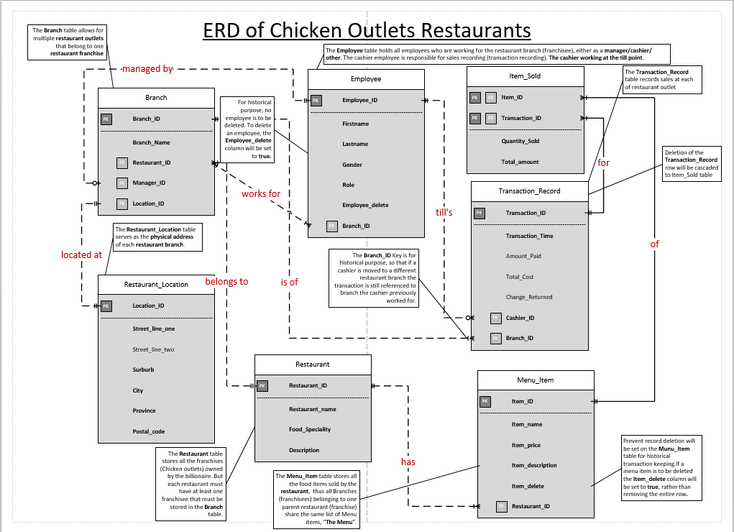

# Dbeaver ERD Drawing

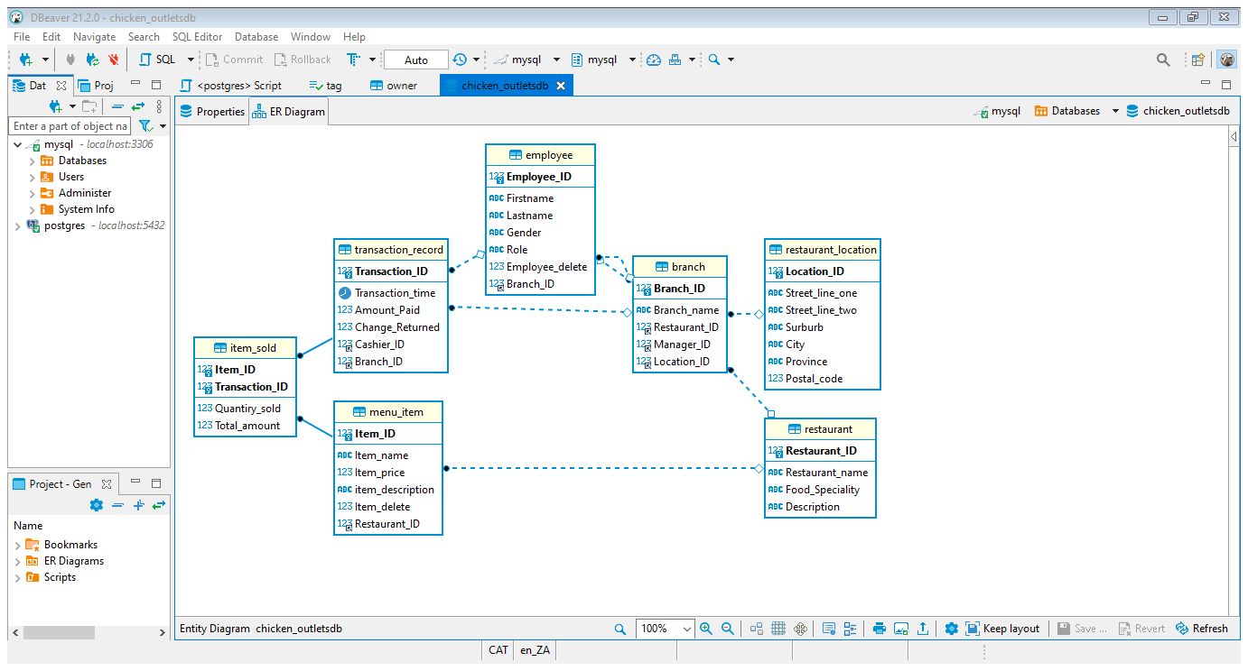

# SQL Query for the receipt (Transaction/Sale):

**Transaction from Garlitos Phoenix:**

Shows all the items bought where the Transaction_ID is 3

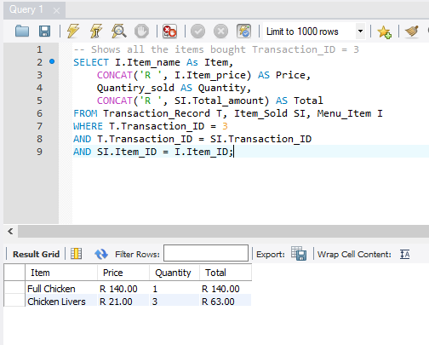

Shows the transaction recorded (sale made\receipt data) where the Transaction_ID is 3

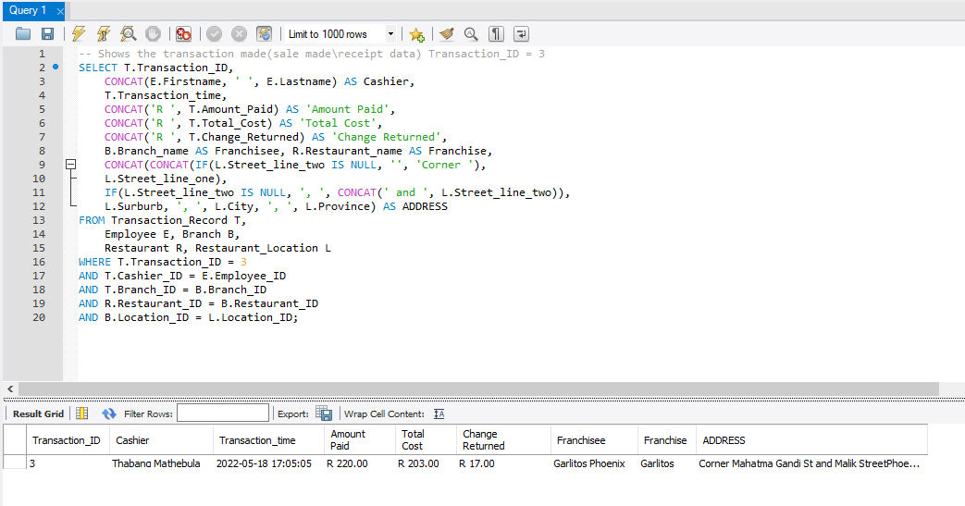

## Transaction from KFC Pretoria Central:

Shows all the items bought where the Transaction_ID is 1

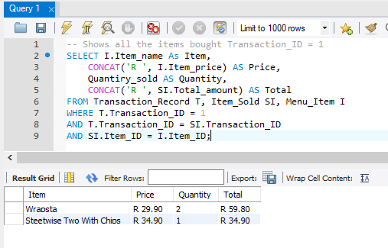

Shows the transaction recorded (sale made\receipt data) where the Transaction_ID is 1

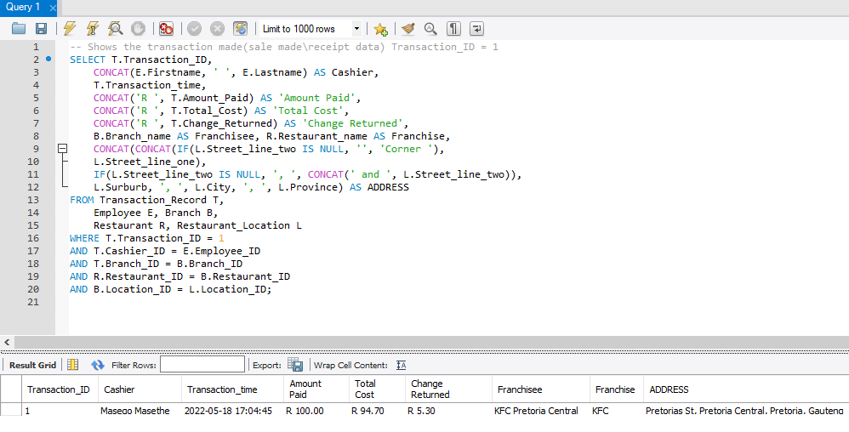

## The SQL statement below shows all the transaction from a franchise:

Shows all the sales of KFC as a franchise.

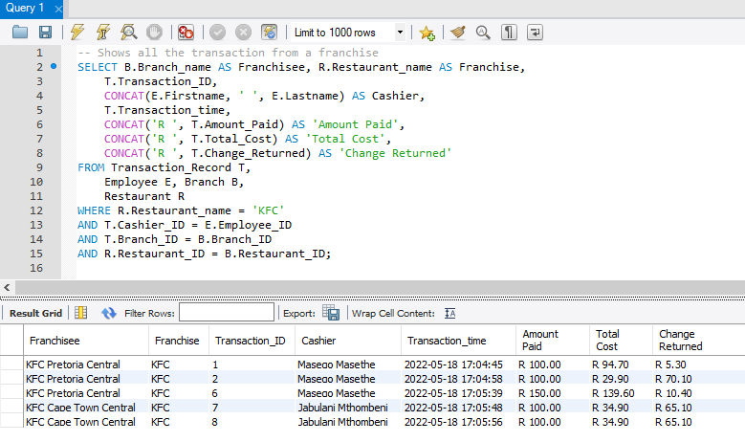

## The SQL statement below shows all the transaction from a franchise:

Shows all the sales of KFC Pretoria Central as a franchisee.

